HYDRAULIC MACHINES
Pelton Turbine | Francis Turbine | Kaplan Turbine
Similarity Law | Cavitation
- PELTON TURBINE:
$$H_{g}=H+H_{f}$$  $$H={\left(\frac{P}{ρg}+\frac{V^{2}}{2g}\right)}_{inlet of nozzle}=\frac{V^{2}}{2g}+H_{fn}$$  $$V=\sqrt{2g\left(H-H_{fn}\right)}=C_{V}\sqrt{2gH}$$ |  |  | $H_{g}=$ Gross Head  $H=$ Head Available at the inlet of the nozzle  $H_{f}=$ Head Loss in the Penstock  $H_{fn}=$ Head Loss in the Nozzle  $C_{V}=$ Coefficient of velocity (0.9-0.98)  $α=$ Vane Angle $=$ Angle between $\vec{u }$ & $\vec{V }$  $β=$ Blade Angle $=$ Angle between $\vec{u }$ & $\vec{V_{r}}$  $\vec{V }=$ Absolute Velocity of Water  $\vec{V_{r}}=$ Relative Velocity of Water w.r.t. Bucket  $\vec{u }=$ Bucket Velocity  $K=$ Bucket Friction Coefficient (0.9-0.98)
Force exerted by jet on the bucket:
$$F=\left(\begin{aligned}Mass Striking on the \\ Bucket per unit time\end{aligned}\right)\left(\begin{aligned}Decreasing in the vel. \\ in direction of force\end{aligned}\right)$$
$$\vec{V }=\vec{u }+\vec{V_{r}}$$ | $$V_{r1}=V-u$$ | $$V_{r2}=K\left(V-u\right)$$
$$F=\dot{m}\left(\vec{V_{r1}}-\vec{V_{r2}}\right)=\dot{m}\left[\left(V-u\right)+V_{r2}\cos{β_{2}}\right]$$
$$F=\dot{m}\left(V-u\right)\left[1+K\cos{β_{2}}\right]$$
Torque $T=FR=\dot{m}\left(V-u\right)\left[1+K\cos{β_{2}}\right]R$  Power Generated by Runner:  $$RP=Tω=Fu$$ |  |  | Mass Striking,  For Single Bucket, $\dot{m}=ρa\left(V-u\right)$  For Multiple Bucket, $\dot{m}=ρaV$
Wheel Efficiency:  $$η_{w}=\frac{RP}{KE}=\frac{2\left(V-u\right)\left[1+K\cos{β_{2}}\right]}{V^{2}}=f(u)$$  Condition For maximum $η_{w}$, $u=V/2$ |  |  | $KE=\frac{1}{2}\dot{m}V^{2}=$ Kinetic Energy per unit time,  $$η_{w, max}=\frac{1-K\cos{β_{2}}}{2}$$
$N_{R}=$ Run Away Speed = Maximum Possible Speed of Turbine Bucket (It can be Theoretical or Actual)
Turbines are designed at $N_{R}$ for Safety Aspect. Because of No load condition Turbines have max. Stress at $N_{R}$

Nozzle Efficiency | Hydraulic Efficiency |  | Mechanical Efficiency |  | $HP=ρgQH=$ Hydraulic Power  $RP=$ Runner Power  $SP=$ Shaft Power
$$η_{n}=\frac{KE}{HP}=C_{V}^{2}$$ | $$η_{h}=\frac{RP}{HP}=η_{n}η_{w}$$ |  | $$η_{m}=\frac{RP}{SP}$$
Overall Efficiency: $η_{o}={SP}/{HP}=η_{h}η_{m}=η_{n}η_{w}η_{m}$
Jet Ratio |  | Speed Ratio |  |  |  | No of Buckets on Wheel
$$m=\frac{Wheel Diameter}{Jet Diameter}=\frac{D}{d}$$ |  | $$K_{u}=\frac{u}{V_{th}}=\frac{u}{\sqrt{2gH}}≅\frac{u}{V}$$ |  |  |  | $$Z=0.5m+15$$  It’s Tygun’s Formula
Relation between frequency of AC & Runner Speed:  1 Rev. = 1 Cycle of AC |  |  |  | $$f=\frac{PN}{60}, Where P=No. of Poles.$$
- FRANCIS TURBINE:
Spiral Casing: Distribute water equally to all guide vanes.  Guide Vanes: It guides water for smooth entry of water. It acts like nozzle (Convers pressure partially into KE). It Controls discharge through the runner.  Runner: To generate torque/ Power output. Pressure decreases (Nozzle Effect & Centrifugal Force) and KE is also decreases.  Old Turbine: Radial Entry & Radial Exit.  Morden Turbine: Radial Entry & Axial Exit. |  | 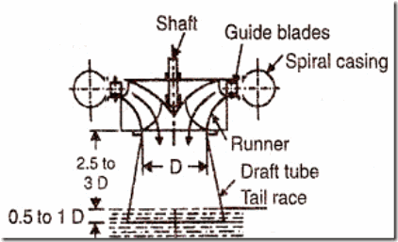
$\vec{V_{w}}=$ Velocity of Whirl $=$ Component of $\vec{V }$ along $\vec{u }$  $\vec{V_{f}}=$ Velocity of Flow $=$ Component of $\vec{V }$ Perpenticular to $\vec{u }$ | $α=$ Guide Vane $=$ Angle between $\vec{u }$ & $\vec{V }$  $β=$ Runner Blade $=$ Angle between $\vec{u }$ & $\vec{V_{r}}$
Euler’s Turbine Equation:
$$\left(\begin{aligned}Torque Generated \\ By Runner\end{aligned}\right)=\left(\begin{aligned}Angular Momentum lost \\ By Water Per unit time\end{aligned}\right)$$  $$T={\left(\vec{r }×\dot{m}\vec{V }\right)}_{1}-{\left(\vec{r }×\dot{m}\vec{V }\right)}_{2}$$ | $$T=r_{1} \dot{m}\vec{V_{w1}}-r_{2} \dot{m}\vec{V_{w2}}$$  $T=ρQ\left(r_{1}\vec{V_{w1}}-r_{2}\vec{V_{w2}}\right)$ Euler eq. for Turbo M/c.  $T=ρQ\left(r_{2}\vec{V_{w2}}-r_{1}\vec{V_{w1}}\right)$ Euler eq. for Pumps.
Inertial Frame has Zero acceleration.
Discharge Through Francis Turbine: | $$Q_{i}=πD_{1}B_{1}V_{f1}$$ | $$Q_{e}=πD_{2}B_{2}V_{f2}$$
Torque Generated by Runner: | $$T=ρQ \left[r_{1}V_{w1}\right]$$
Power Generated by Runner: | $$RP=Tω= ρQ V_{w1}u_{1}$$
Various losses in Francis Turbine:
Hydraulic Efficiency | Mechanical Efficiency | Overall Efficiency
$$η_{h}=\frac{RP}{HP}=\frac{V_{w1}u_{1}}{gH}$$ | $$η_{m}=\frac{RP}{SP}$$ | $$η_{o}=\frac{SP}{HP}=η_{h}η_{m}$$
Speed Ratio (0.75-0.82) | Flow Ratio (0.15-0.30) | Head Developed by Turbine
$$K_{u}=\frac{u_{i}}{\sqrt{2gH}}=f\left(\begin{matrix}Geometric \\ Shape\end{matrix}\right)$$ | $$K_{f}=\frac{V_{fi}}{\sqrt{2gH}}=f\left(\begin{matrix}Geometric \\ Shape\end{matrix}\right)$$ | $$H_{e}=\frac{V_{w1}u_{1}}{g}$$
- KAPLAN TURBINE:
- Spiral Casing: Same as Francis Turbine  - Guide Vanes: Same as Francis Turbine  - Swirl/ Whirl Chamber: At exit of Guide Vanes, 2 Component of velocities are present in the flow. 1) Radial 2) Tangential (Responsible for the whirling of the flow). Hence, Angular momentum of fluid partial is conserved in swirl chamber. $V_{w}r=Const.$ (Free Vortex Flow).  - Runner: $u_{r}=rω$ hence, velocities are changing w.r.t radius. So, velocity diagram will be different at different radial location. Here, Runner blades are adjustable. So, it’s very costly.  Propeller Turbines has fixed blades.  - Draft Tube: |  |  |  | 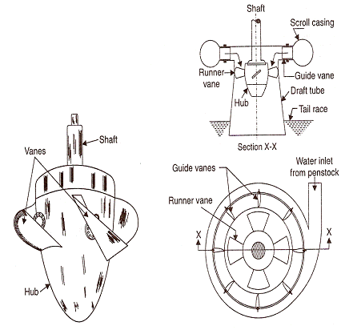
$$u_{1}=u_{2}=rω$$ | $$V_{f}=V_{f1}=V_{f2}=\frac{Q}{A_{f1}}=\frac{Q}{A_{f2}}$$ | $$A_{f1}=A_{f2}=\frac{π}{4}\left(D_{t}^{2}-D_{h}^{2}\right)$$ |  | $D_{t}=$ Blade Tip diameter  $D_{h}=$ Hub diameter
Discharge Through Kaplan Turbine: |  |  | $$Q=A_{f1}V_{f1}=A_{f2}V_{f2}$$
Torque Generated by Runner: |  |  | $$T=ρQ \left[r_{1}V_{w1}\right]$$
Power Generated by Runner: |  |  | $$RP=Tω= ρQ V_{w1}u_{1}$$
Hydraulic Efficiency: |  |  | $$η_{h}=\frac{RP}{HP}=\frac{V_{w1}u_{1}}{gH}$$
Torque, RP, Hydraulic Efficiency for any radial location will remains exactly same.
Various losses in Kaplan Turbine:
Hydraulic Efficiency | Mechanical Efficiency | Overall Efficiency
$$η_{h}=\frac{RP}{HP}=\frac{V_{w1}u_{1}}{gH}$$ | $$η_{m}=\frac{RP}{SP}$$ | $$η_{o}=\frac{SP}{HP}=η_{h}η_{m}$$
Speed Ratio (1.3-2.3) | Flow Ratio (0.35-0.75) | Head Developed by Turbine
$$K_{u}=\frac{u_{tip}}{\sqrt{2gH}}=f\left(\begin{matrix}Geometric \\ Shape\end{matrix}\right)$$ | $$K_{f}=\frac{V_{f}}{\sqrt{2gH}}=f\left(\begin{matrix}Geometric \\ Shape\end{matrix}\right)$$ | $$H_{e}=\frac{V_{w1}u_{1}}{g}$$
- SIMILARITY LAW:
Valid under homologous condition:  - Model & Prototype are geometrically similar.  - Corresponding velocity triangles are also similar.  $η$ of the Hydraulic Machine depends on Velocity triangle. | $$d∝D$$  $$L_{r}=\frac{D_{m}}{D_{P}}=\frac{d_{m}}{d_{P}}$$ | $$Velocity∝\sqrt{H}$$  $$\frac{{\left(V_{r1}\right)}_{m}}{{\left(V_{r1}\right)}_{P}}=\frac{{\left(u_{1}\right)}_{m}}{{\left(u_{1}\right)}_{P}}=\frac{V_{m}}{V_{P}}=\sqrt{\frac{H_{m}}{H_{P}}}$$
$$u=πDN$$ | $$ND∝\sqrt{H}$$ | $C_{H}=$ Head Coefficient
$$Q=a V=\left(π/4\right)D^{2}\sqrt{2gH}$$ | $$Q∝D^{2}\sqrt{H}$$ | $C_{Q}=$ Discharge Coefficient
$$P=η_{o}ρgQH$$ | $$P∝D^{2}H^{3/2}$$ | $C_{P}=$ Power Coefficient
Important $π$ Terms Valid for all Hydraulic Machines:
$$\frac{Q}{ND^{3}}$$ | $$\frac{gH}{N^{2}D^{2}}$$ | $$Re=\frac{ρND^{2}}{μ}$$ | $$\frac{P}{ρN^{3}D^{5}}$$ | $$\frac{E/ρ}{N^{2}D^{2}}$$
SPECIFIC SPEED ($N_{S}$):
$$C_{H},C_{Q},C_{P},C_{S}=f\left(\begin{matrix}Geometric \\ Shape\end{matrix} ,\begin{matrix}Shape of Velocity \\ Triangle\end{matrix}\right)$$ | $$Speed Coefficent=C_{S}=C_{H}\sqrt{C_{P}}=\frac{N\sqrt{P}}{H^{5/4}}$$
Specific Speed is the speed coefficient at maximum efficiency. Specific Speed is function of geometric shape only.
Selection of turbine based on specific Speed:
$P=$ Based upon quantity of water available or power requirement.  $N=$ Based upon gearbox & type of generator used. | $H=$ Based upon heat available.
Based on the graph of Efficiency Vs. Specific Speed, the suitable turbine is selected.
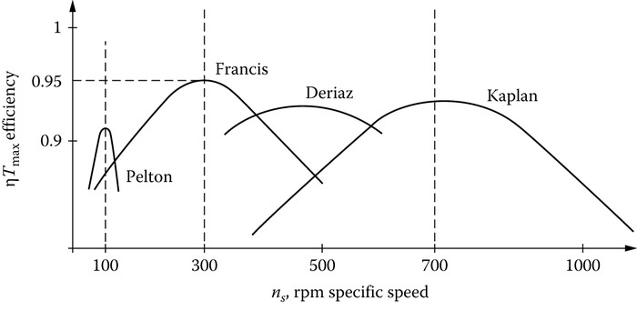
TURBINE | TYPE | FLOW DIRECTION | $$N_{S}\left({rpm \sqrt{KW}}/{m^{5/4}}\right)$$ | HEAD (M) | DISCHARGE
Pelton | Impulse | Tangential | 8-30 | High (50-1500) | Low
Francis | Reaction | Radially inward | 40-400 | Medium (25-350) | Medium
Kaplan | Reaction | Axial | 300-900 | Low (2-40) | High
Note:
- For Pelton Turbine Power per jet is considered in case of MultiJet turbine.
- Power is always considered in “KW”

DRAFT TUBE:
- Allows installation of turbine above tail-race without effective loss in net head.
- Recovers KE loss at exit partially.
Head Developed by Turbine  $$H_{T}=B_{1^{'}}-B_{2^{'}}≅\frac{P_{1^{'}}-P_{2^{'}}}{ρg}$$ | From the Bernoulli Eq. (2’-3),  $$\frac{P_{2^{'}}}{ρg}+\frac{V_{2^{'}}^{2}}{2g}+\left(H_{S}+y\right)=\left(\frac{P_{atm}}{ρg}+y\right)+\frac{V_{3}^{2}}{2g}+0+h_{fd}$$  $$\frac{P_{2^{'}}}{ρg}=\frac{P_{atm}}{ρg}-\left(H_{S}+\frac{V_{2^{'}}^{2}-V_{3}^{2}}{2g}-h_{fd}\right)≤\frac{P_{atm}}{ρg}$$
$H_{S}=$ Recovery of lost Head,
$\frac{V_{2^{'}}^{2}-V_{3}^{2}}{2g}=$ Partial Recovery of KE lost,
EFFICIENCY OF DRAFT TUBE ($η_{d}$):
$$η_{d}=\frac{\begin{aligned}Actual Recovery \\ of KE head\end{aligned}}{\begin{aligned}KE head at inlet \\ of draft Tube\end{aligned}}=\frac{\frac{V_{2^{'}}^{2}-V_{3}^{2}}{2g}-h_{fd}}{\frac{V_{2^{'}}^{2}}{2g}}$$ | $$η_{d}=\frac{\begin{aligned}Actual Recovery \\ of KE head\end{aligned}}{Theretical Recovery}=\frac{\frac{V_{2^{'}}^{2}-V_{3}^{2}}{2g}-h_{fd}}{\frac{V_{2^{'}}^{2}-V_{3}^{2}}{2g}}$$
- CAVITATION: $P_{min}<P_{Vapour}$ Cavitation starts.
For turbines, Cavitation starts after turbine exit/ before draft tube entry if $P_{2^{'}}<{\left(P_{Vapour}\right)}_{Water}$.
TOMA’S CAVITATION FACTOR $\left(σ\right)$:
$$σ=\frac{H_{a}-H_{S}-H_{V}}{H}$$  Critical Cavitation Factor$\left(σ_{C}\right)$ is given by manufacturer. For Cavitation not to happed, $σ<σ_{C}$. | $H_{a}=$ Head of atmospheric pressure,  $H_{S}=$ Height of Draft tube,  $H_{V}=$ Head of Vapour Pressure,  $H=$ Net head on the turbine,

